Azure dev ops board
The Technical Onboarding Manager (TOM) a 10th Magnitude will use the Azure Dev Ops (ADO) board in their everyday workload. The purpose of the ADO board is to track the assigned applications in a given iteration from planning to migration.
Tutorial
Watch this video to understand how to add applications to the backlog, link child applications to a family, and move the applications across the ADO board.

Transcription of Tutorial
Accessing the ADO board
- Go to dev.azure.com
- Click on the “sign-in” hyperlink
- Select which O365 account you want to sign in with
  - Likely your 10th Magnitude account
- Enter your password (or SSO)
- Land on your user’s ADO board Home screen
  - Titled “10M-Cloud Transformation”
  - This is where you can select from the ADO boards you have been granted access
- Click on whichever project you want to view
Navigating to the ADO Board
- Once the ADO project board loads, you will land on the project’s Summary page
  - Description of the project
  - Project statistics
  - Members with access
- The side navigation menu has options to view the project as a dashboard, boards, repositories, test plans, etc.
  - The TOM will mainly be concerned with the Boards section
- Click on the “Boards” section from the side navigation
- On the upper right corner of the page, ensure “Application” is selected from the dropdown 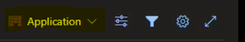
Viewing the ADO Board with Cards
- This is view of the board is what the project team uses to track application across in a given application 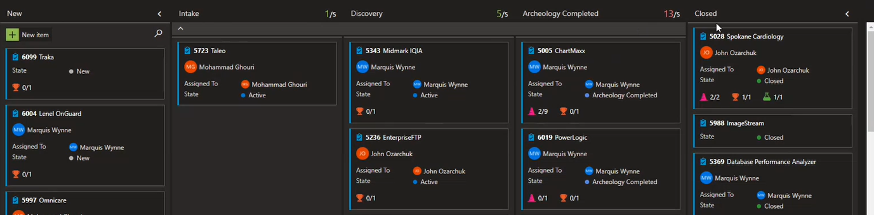
- There are 5 different swimlanes:
  - New = assignments provided to the team at the beginning of the sprint
  - Intake = application that have had an intro call conducted, welcome kit returned, and has an ach review scheduled but not completed.
  - Discovery = arch review is completed, server notes are added, and welcome kit is verified
  - Archeology Completed = ICDC will replicate servers, wait for migration date that was set during the arch review
  - Closed = migration is completed and tested is verified
Viewing the ADO Board as a Backlog
- Switch from the sprint view to the backlog by clicking on the Backlog tab 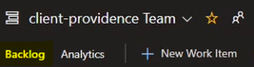
- This view shows the applications in the sprint formatted as a list
  - Ability to view which application instances reside under an app family, as well as any servers that are assigned to an application instance
- Item are shown as
  - Work Item Type = application [family], application instance [child], server
  - Title = the name of the application [family], application instance [child], server
  - State = which swim lane the item is currently in
Adding an Item to the ADO Board
- In the sprint view, click on the New Item button
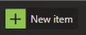
- Type the name of the item you’re adding
  - Typically, you should start with the Application Family name before working down to the application instance
- Click enter to view inside the created card
- Verify the fields at the top of the card are accurate 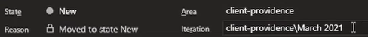
  - State = should be NEW if you’re adding to the ADO board
  - Area = your project name
  - Reason = does not change
  - Iteration = the sprint the item is being added to
- Under Related Work, click “Add link” and select “New Item” from the dropdown 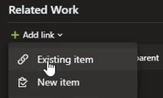
- Add an application instance to the application family/parent card
  - Link type = Child
  - Work item type = Business App CI
  - Title = the name of the application instance
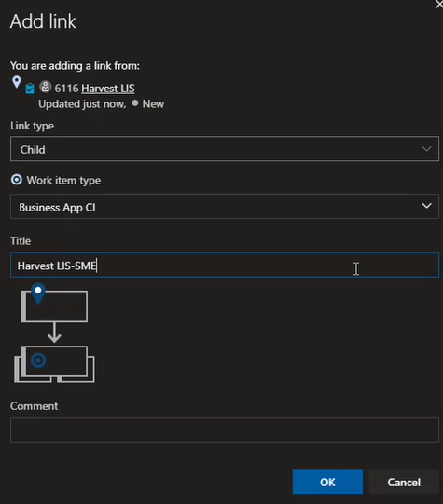
- Click on OK to link the new application instance card to the family/parent app
- Fill out the required fields on the application instance’s card
  - Arch Review Scheduled = date the arch review will take place
  - App Analyst = point of contact for the app instance
  - Discussion = include any pertinent notes for the architects
  - APM Number = APM000_____ assigned to the instance
  - Instance Disposition = typically Lift and Shift
- Save & Close to finalize changes
Add Servers to an Application
- Open the Application family/parent card
- Navigate to Related Work
- Click “Add Link” and select New Item
- Link the server to the family/parent card, not the app instance (child)
  - Link Type = Child
  - Work item type = Server
  - Title = name of the server
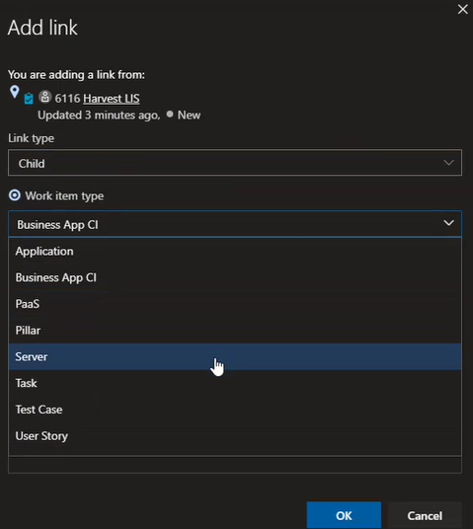
- Fill out the required fields for the server
  - Current Server IP = copy/paste from the Welcome Kit the app owner returned
  - OS Version = copy/paste from the Welcome Kit the app owner returned
  - Environment = either development or production
  - Server Type = either database or application (taken from Welcome Kit)
    - If Citrix, the Citrix team needs to be involved
  - Server Disposition = should almost always be “migrate”
  - App Family = the application parent card the server card is being created under
  - App Instance = the instance provided on the Welcome Kit (column B)
  - APM Number = copy/paste from the Welcome Kit the app owner returned (column A)
  - Link the server = select the app instance the server card is linked t
- Connect the Server to the application instance by clicking Add link > New item
  - Link type = Related
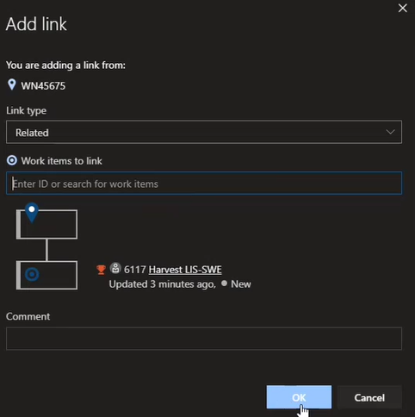
- Server will now be related to the instance 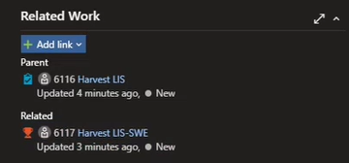
Filters
- At the top of the ADO board (Backlog or Anlytics view) is the Filter
- The Filter has multiple option to query the results viewed on your ADO board
  - Types = view specific items such as applications, business apps, servers, PaaS
  - Assigned to = view cards assigned to a specific user
  - States = view cards in specific swimlanes (active, arch complete, closed, new, etc.)
  - Tags = rarely (if ever) used by TOMs
  - Iteration = view cards allocated to specific sprint(s)
  - Area = rarely (if ever) used by TOMs

Windows in-tool office
An alternative option to viewing the ADO board is to view the data in a Microsoft Excel spreadsheet. This is possible once the TOM installs the Windows InTool Office plug-in.
Installation
Download the In-Tool Office 2019 plug-in here, then follow the directions to complete the installation.
Tutorial
Watch this video to understand how to add servers to connect to project ADO boards, important columns, and publishing data directly to a project’s ADO board.
Transcription
Adding/Connecting to a Server
InTool Office must be installed first
- Open a new Excel spreadsheet
- Navigate to the Team tab in the top navigation
- Click on “New List”
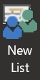
- When the modal come up, click on the Servers button to
  - Another modal opens
- Click the “Add..” button to input the new server’s information
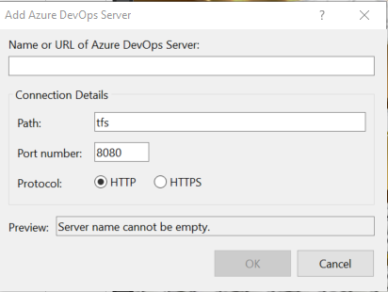
- Enter the URL of the server you’re attempting to connect to
  - Be aware, you must enter https://
  - Ex) https://dev.azure.com/10m-cloudtransformation
- Click OK to close
- Select the board you want to connect to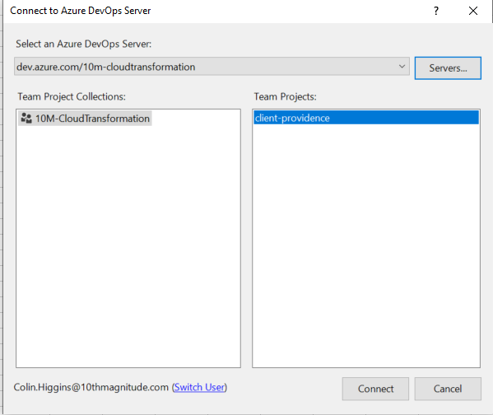
- Click connect
  - Modal comes up for you to select the query list you’ll be using
- Select the defaulted query list > OK
- Data from the ADO board will appear in the spreadsheet
Adding/Removing Columns
To view different data than what was pulled from the query, you can add or remove columns
- In the top navigation, click on the Teams tab
- Click on “Choose Columns”
- The columns to the left are the options you have to add to the spreadsheet, the columns to the right are the columns currently being shown (can be removed from the spreadsheet) 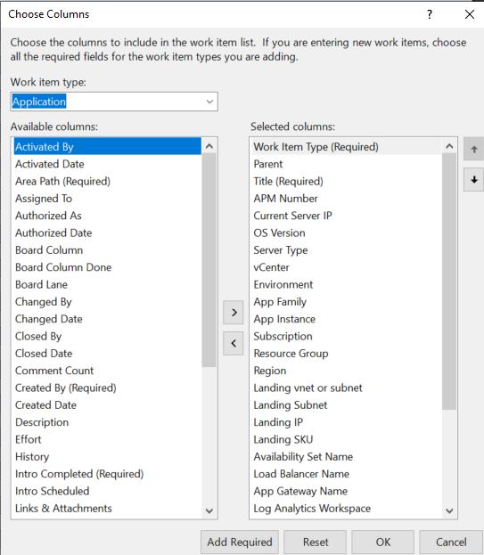
- Add data by clicking on the column, then clicking on the arrow to send it from one column to another
- Common columns to use are:
  - Work Item Type
  - APM Number
  - Board Column
  - Assigned To
  - Title – the name of the application
  - Primary Contact Name
  - Other App Contacts
  - Iteration Path
Publishing
Any changes you make to the data can be published and changed on the ADO board
- Update any data you need in the Excel
- Click on the “Team” tab in the top navigation
- Click the Publish button to make your changes
